Week 10: Tides LAB Assignment

Student Full Name
Institution Affiliation
Course Details
Instructor Full Name
Due date

Week 10: Tides LAB Assignment

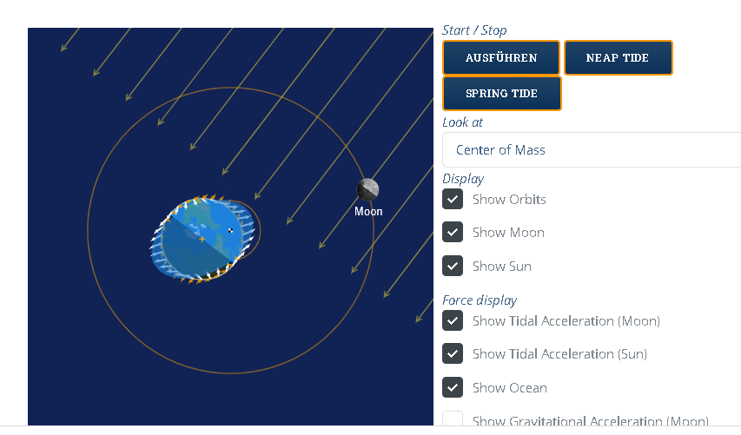
Figure 1: Tidal Simulation Applet
Q. 1
The yellow-orange arrows in the diagram represent the rays of the Sun (Show sun). The Sun produces light rays that are directed towards the earth as it rotates in orbit. In the Sun, rays are components of electromagnetic energy that is emitted out by the Sun. While the Sun is up in the sky, the light we see is filtered and dispersed sunshine, while when it is low, it is evident as bright sunlight. When clouds do not obscure sunlight, it gives heat energy.
Q. 2
The small orange arrows from the earth represent the Tidal acceleration of the Sun, whereas the small white arrows show the tidal acceleration of the moon. A tidal acceleration is just an influence that occurs on a specific globe while a satellite is circling the planet. Like the earth, its gravitational force from the relationship with another celestial body occurs. Thus, a primary with a high periapical eccentricity rotates more slowly. A prograde eccentricity of zero (with the same magnitude but opposite direction) induces an ongoing recession of satellites in a circular orbit. This happens more often when the outer radius of the larger object approximately equals the inner radius of the minor one, resulting in the minor body gaining or blocking the larger one (US Department of Commerce, 2021).
Q 3.
The moon causes two water bulges on the earth. Since the moon moves around the earth, the next high tides happen 50 minutes later. Therefore, within an hour, four water bulges are created due to the gravitational effect of the moon, respective to its rotation around the earth. However, the bulging is not only caused by the gravitational pull of the moon but also inertia. The moon pulls outward the water on the earth’s surface to form bulges—consequently, inertial acts on the opposite side of the earth, resulting in another bulge (US Department of Commerce, National Oceanic and Atmospheric Administration, 2019).
Q. 4
The Sun’s gravity forms one bulge at the opposite side of the caused by the moon. After 50 minutes, another bulge formed can be explained from the sum rotation on its axis and the moon’s movement around the earth. In addition to that, the moon's gravity exerts a significant influence on all bulges, for that matter (US Department of Commerce, National Oceanic and Atmospheric Administration, 2019). So, if the powers of the moon and the Sun's gravitational attraction are weak, their relationship is always complicated, but that can never be the case.
Q. 5
Tides are never of the same height. Two low tides and high tides are produced per day by the actual mechanisms between the moon and the earth. Each pair of high or low tides per day is not of equivalent height since the moon is positioned at different angles concerning the earth. According to NOAA National Weather Service - Glossary (2020), the tide rises and regularly falls; thus, normal tides occur when the gap between the planet and the moon changes. 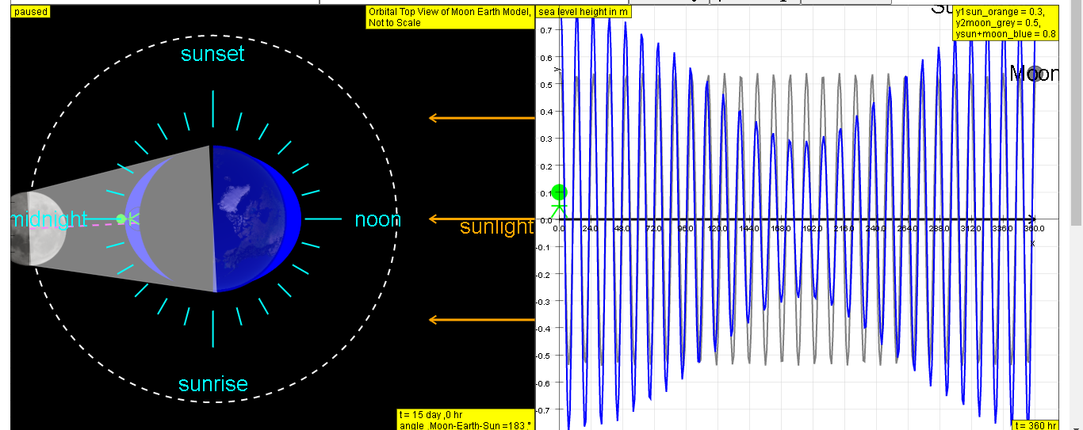
Figure 2: y vs t due to moon
Q. 6
The high tides are not of equivalent height. The same applied to low tides. Each pair of high or low tides per day is not of equivalent height since the moon, the Sun, and the earth are positioned at different angles concerning the earth. The tide rises and regularly falls; thus, when the gap between the planet, the Sun, and the moon changes, similar tides result
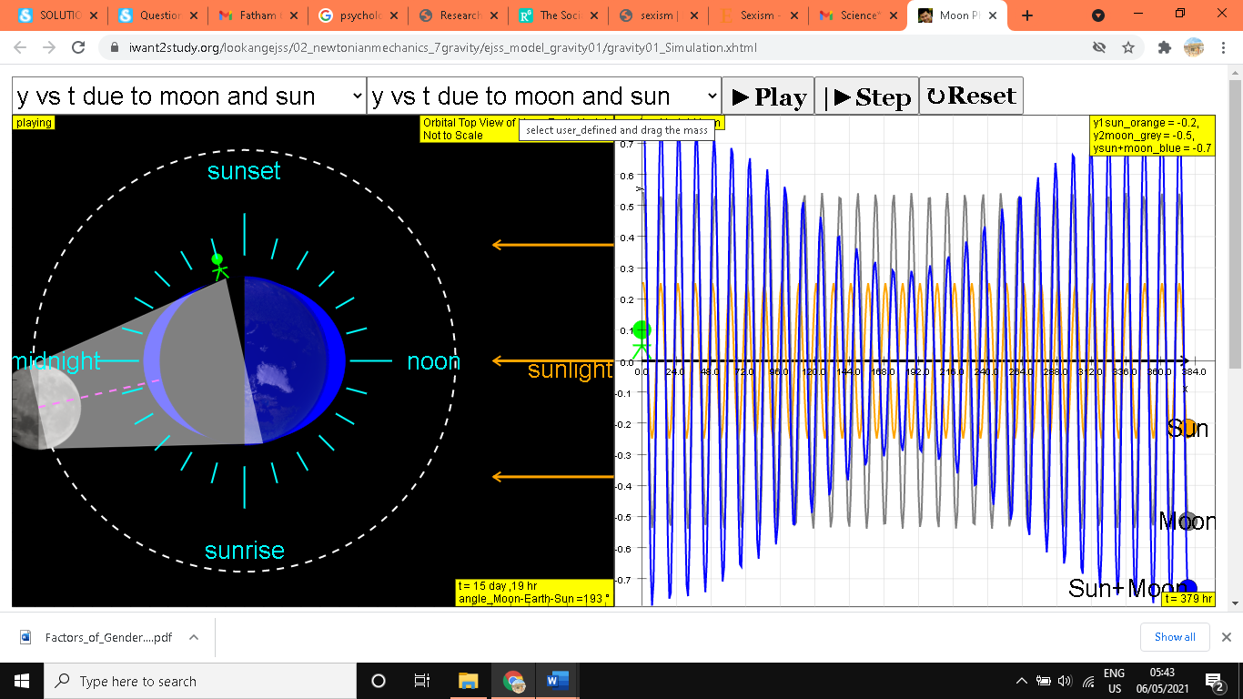
Figure 3: y vs t due to moon and sun.
Q. 7
Then simulation is depicting low and high tides. Most parts of the earth experience low and high tides. When high tides possess the same size, or when two lows have the same size, the tidal pattern is a semidiurnal (semi-daily) tide. Otherwise, the tide pattern is referred to as a mixed semi-daily tidal pattern. The parts of the earth may, however, possess only low and high tide. Such a tidal pattern is given the name diurnal tide (US Department of Commerce, 2020).

References
NOAA’s National Weather Service - Glossary. (2020). Forecast.weather.gov. https://forecast.weather.gov/glossary.php?word=tides
US Department of Commerce, N. O. and A. A. (2020). Types and Causes of Tidal Cycles - Tides and Water Levels: NOAA’s National Ocean Service Education. Oceanservice.noaa.gov. https://oceanservice.noaa.gov/education/tutorial_tides/tides07_cycles.html#:~:text=If%20the%20high%20and%20low
US Department of Commerce, N. O. and A. A. (2021). Tides and Water Levels, Gravity, Inertia, and the Two Bulges, NOS Education Offering. Oceanservice.noaa.gov. https://oceanservice.noaa.gov/education/tutorial_tides/tides03_gravity.html#:~:text=On%20the%20%E2%80%9Cnear%E2%80%9D%20side%20of
US Department of Commerce, National Oceanic and Atmospheric Administration. (2019). Frequency of Tides - The Lunar Day - Tides and water levels: NOAA’s National Ocean Service Education. Noaa.gov. https://oceanservice.noaa.gov/education/tutorial_tides/tides05_lunarday.html

